FUEL PRESSURE GAUGE KIT
INSTALLATION INSTRUCTIONS

DISCLAIMER – CAUTION!
READ THIS BEFORE DOING ANYTHING!
READ COMPLETE DIRECTIONS!
We have put together this kit for people who have been requesting a kit to go along with the hood mounted brackets we have sold for a while now. CAUTION must be observed for a safe installation, we will not be held responsible for any damage to your vehicle either electrically, fire damage or paint damage. Below are CAUTION steps that must be followed. If you don’t feel comfortable doing this yourself, get a qualified mechanic to do this for you. The assembled hose is 48” long and has been pressurized to check for leaks before shipping. It may be shortened if desired, but must be properly reassembled to prevent leaks. There is a video link on our site that shows how to do this.

#1 – Disconnect the negative battery cable! Can’t emphasis this enough, you will be wrenching right around the back of the alternator and if the cover is missing on the positive power stud you could cause a short circuit if accidentally contacting the stud with a wrench, not to mention a possible fire.

#2 – You MUST relieve the fuel pressure before prepping the fuel rail and connecting the braided hose. We suggest running the motor with the fuel pump connector by the tank until it stalls and then relieving whatever pressure is left by depressing the schrader valve with a rag around it to catch any fuel. Dispose of the rag safely.

#3 – There is no need to use teflon tape on any of the connections. AN fittings do not require it.

#4 – You can test your connections before attaching the gauge/bracket assembly to eliminate paint damage to the hood if you might have a leak. That is up to you.

Now let’s get started with the installation!

- Carefully position the gauge bracket on the flat surface under the hood to determine where you are going to drill the holes for the bracket. On my GN I had good luck clearance wise by mounting it in line with the master cylinder. You might want to tape the bracket in place temporarily with painters’ masking tape so you can check out the position of the bracket. You don’t want the bracket right up against the hood edge trim piece! Also be sure to allow clearance for your wiper blade arm. Remember, you have to determine your hose routing as well, if you are careful, you will only have to drill four holes.

- Once final position is determined, use a punch to mark where to drill. Remove the tape and bracket. Use a drill bit smaller than the screws supplied and drill the four holes. IMPORTANT!!!!! Make sure your drill bit is not too long, you don’t want to drill thru the top of your hood or ding it from the inside. I suggest wrapping the drill bit with duct tape or slip a rubber hose over it to prevent it from going to far.

- It is easiest to assemble the gauge and cup as a unit including attaching the 180 degree fitting to the gauge. The gauge supplied with the kit requires that you snip off the threaded studs for clearance in the cup. A wire dykes will cut them easily. NOTE! If you want, you can also test for leaks before attaching the gauge setup to the hood. Rest the gauge under the hood on some towels and turn the key on.

- Attach your Autometer gauge mounting cup to the bracket with the supplied bolts, suggest a dab of LocTite on them to prevent the screws from backing out. These are 10/32” threads if you need a different length.
The 180 degree fitting should be connected to the gauge after it is assembled into the cup. There is just enough room to tighten it up, use paint masking tap to protect the finish on the cup when tightening.
Protect your hood from scratches before attempting to attach the assembled gauge/bracket. You can run the braided line on either side of the gauge. (see photo) For extra securing of the hose, you can use a cushion clamp under the hood on one of the screws. You will need to decide where to hook up the positive wire for the light. (wire is not supplied) You can run it all the time if you connect to an ignition on circuit but the best way is to find a wire that comes on with the headlights. Ground wire for the light can attach to the firewall. I suggest using small split conduit for the wires for a clean look.

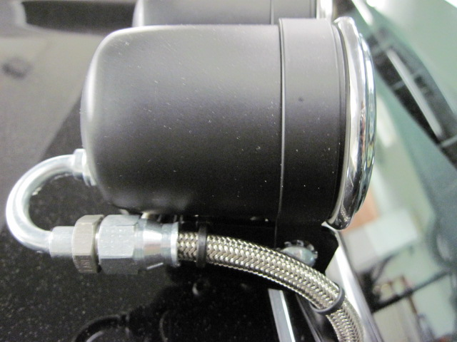

- Now you have to route the hose over to the connection at the end of the fuel rail. You need to leave some slack on the hose so the hood closes properly and the hose does not rub anything or interfere with the wiper rods. Braided hose can be very abrasive so be sure to secure with tie wraps as needed. Everybody has their own way of routing the hose so we leave that up to you. The line is 48” long so there is plenty of ways to do it. CAUTION! If you are still running an EGR valve be aware that it can get very hot and be sure the braided hose has enough clearance from it.

- Connection to the fuel rail (see photo) REMINDER! Did you relieve the fuel pressure?? You will need to remove the Schrader valve from the end of the fuel rail. This is the same as taking the valve out of a tire stem, you just need to have the proper tool which available at any auto parts store. You can position the 180 degree fitting so the hose runs above or below the fuel rail. If running above the fuel rail be sure you leave clearance to the throttle cable. Secure with tie wraps, for a stealth look you can put the braided line inside black split wire conduit.

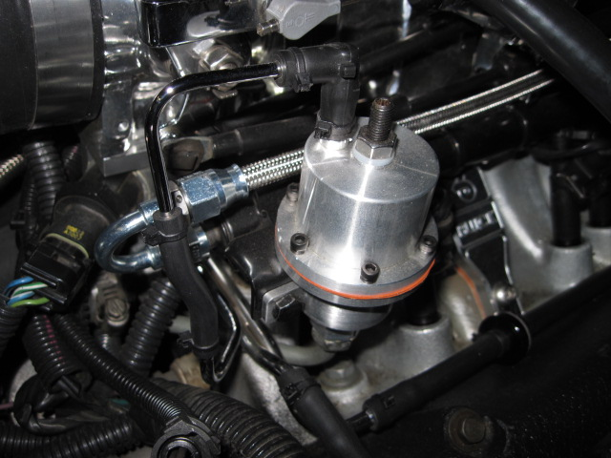

- Tighten the connection securely, position of fitting can be changed by slightly loosening the connection and rotating it, then hold it and tighten.

- Getting ready to start. Since our cars have an electric fuel pump it is not necessary to start the motor to test your installation. Just turn the key and look for leaks at the gauge and fuel rail. NOTE! If you want, you can also test for leaks before attaching the gauge setup to the hood. Rest the gauge under the hood on some towels and turn the key on.

ADDITIONAL TIP! You might want to put a piece of slit vacuum or fuel line on the edge of the hood under the gauge bracket, this will reduce any vibration of the gauges and the braided hose rubbing the hood.

